 |  | Contact: |  | Email:
 |  | 215-809-7674 |  | kpruss@neshaminy.org

Ms. Karen Pruss, Business, Computer & IT Teacher
Welcome Back to School 2024-25

7th Grade: Emerging Technologies & Skills Course Overview

Welcome to the exciting world of computer science! I’m thrilled to introduce your child to this new learning adventure in our Emerging Technologies & Skills class. This year, your child will learn Python, one of the most widely used and versatile programming languages in the world. In class, your child will be working on lessons and personalized projects in Python. Collaboration amongst the class is encouraged as students learn to debug their programs and work with others in a problem-sovling environment.

  Why Python?  - Essential Skills: Python is widely used in tech and many other industries. In school, Python programming is key for developing problem-solving skills, collaboration with peers, logical thinking, and creativity.  - Real-world Applications: Projects are based upon real-world examples and each student customizes end of lesson projects based upon their interests and creativity.  - Flexible Learning: Students will work on individual Python projects at their own pace, aiming for personal excellence. | 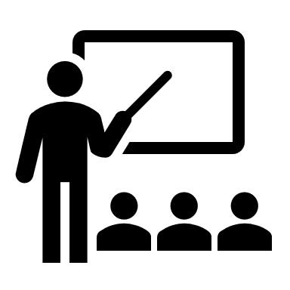  Class Structure  - Specials Rotation: One of five “specials” that runs for 36 consecutive days, called quints.  - Canvas Learning Management System: All lessons and assignments are available on Canvas, Neshaminy’s learning management system.  - Absences: Missed a day? No problem – students can find everything they need in Canvas to stay on track.  - Resubmissions Encouraged: Mistakes are a part of learning. Students can resubmit assignments for regrading without penalty.

